**Professional Behavior Document #2**

CIT360 - Jeremy Alkire

Brother Lawrence

1. **Interacting Professionally with the Instructor:**

It’s been a short while since I last made a familiarity submission, so we’ve not had too much time to interact since then, barring my most recent messages to you. I’ve tried my best to be professional in our chats, though!

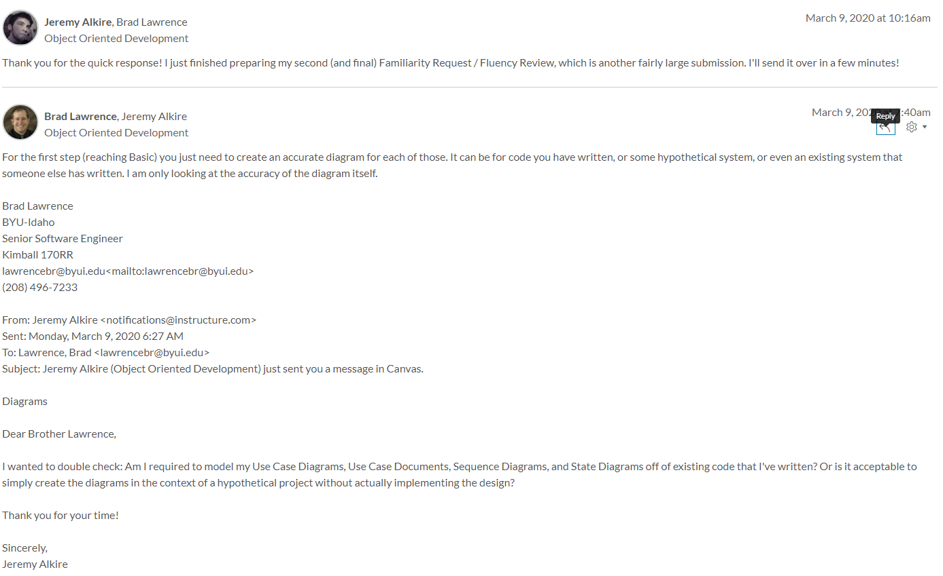

1. **Interacting Helpfully and Professionally with Other Teams:**

My last familiarity was four weeks ago, so in this area I’ve also had a small window of time to interact with other people. I’ve missed one developer forum since, which I can’t attribute to much more than a busy schedule. But, barring that, I’ve tried to help people as I can in the developer forum:

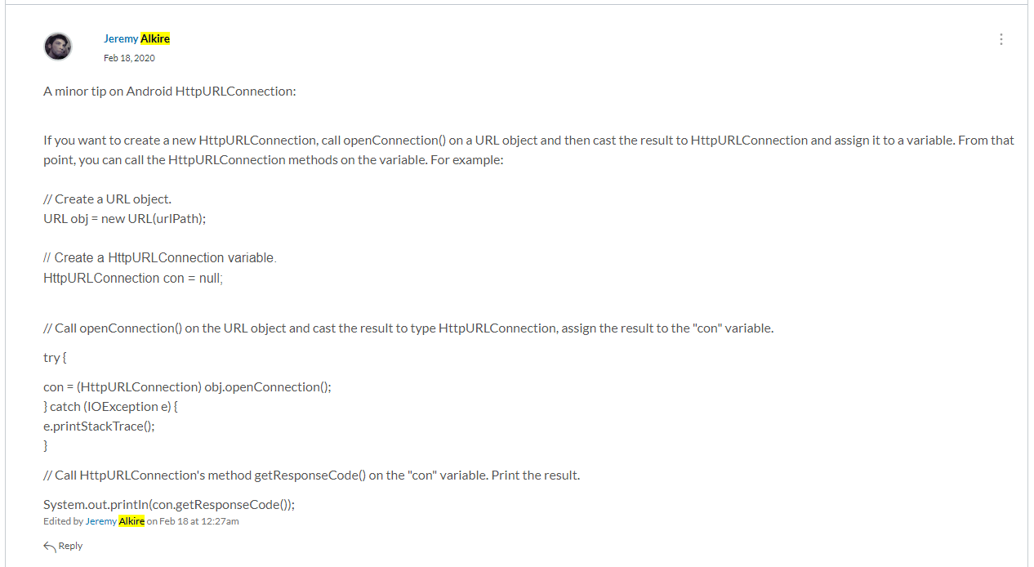

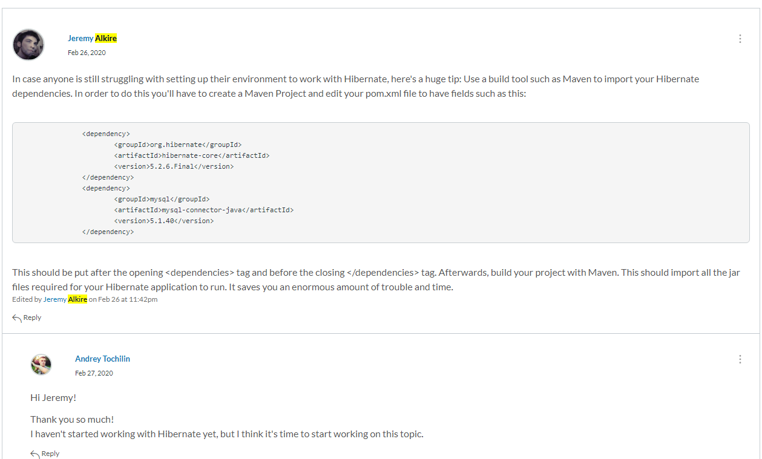

1. **Supporting the Team by Teaching, etc.**Our most recent meetings were not recorded, though I can say I spent a significant amount of time (hours) trying my best to assist Logan with his areas of difficulty. Most of his problems (in my opinion) were due to having his environment set up improperly, which made helping him quite the challenge. His project was set up in a very complicated, error-prone manner (many Eclipse projects, rather than one project with multiple packages). I suspect this was due to many different attempts at online tutorials, which is entirely understandable. I spent most of my time trying to assist him with Hibernate and Servlets.  
     
   In addition, I did what I was able to answer Yamilka’s questions about using Hibernate inside of a console application that accepts user input, allowing her to insert data dynamically into a database. This was done both via video chat and our group discussion board. From her replies, the help seemed to have been beneficial!

#1

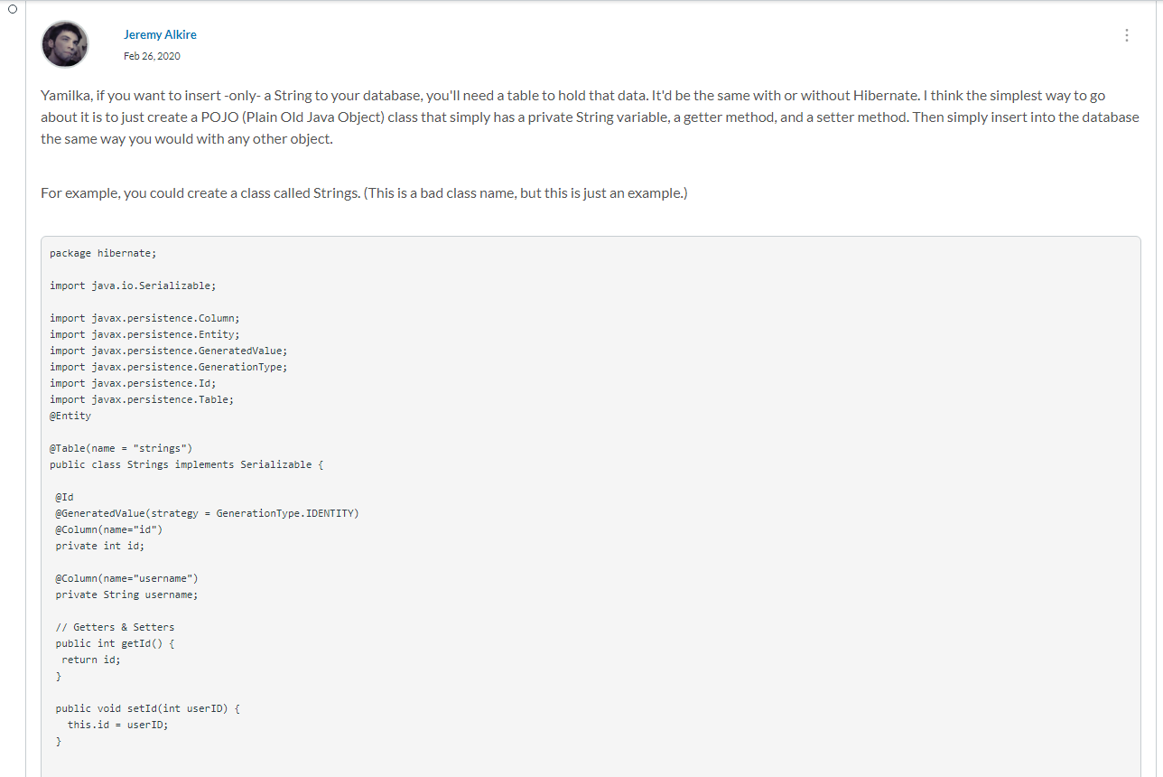

#2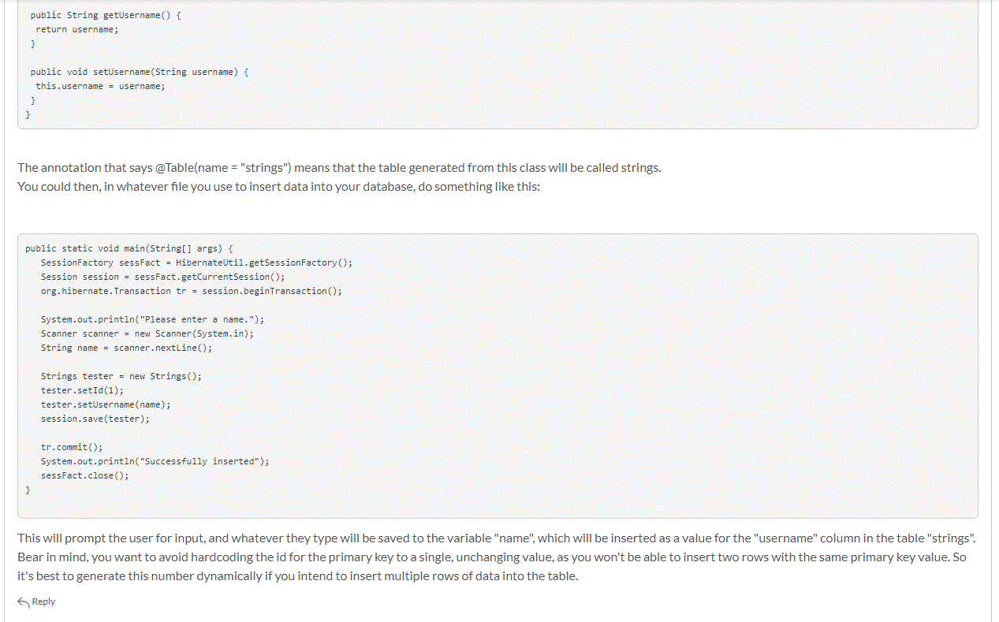

#3

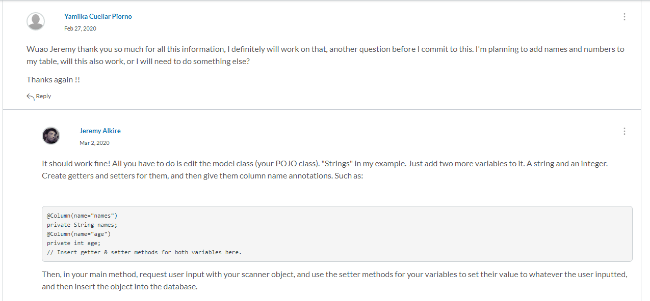

#4

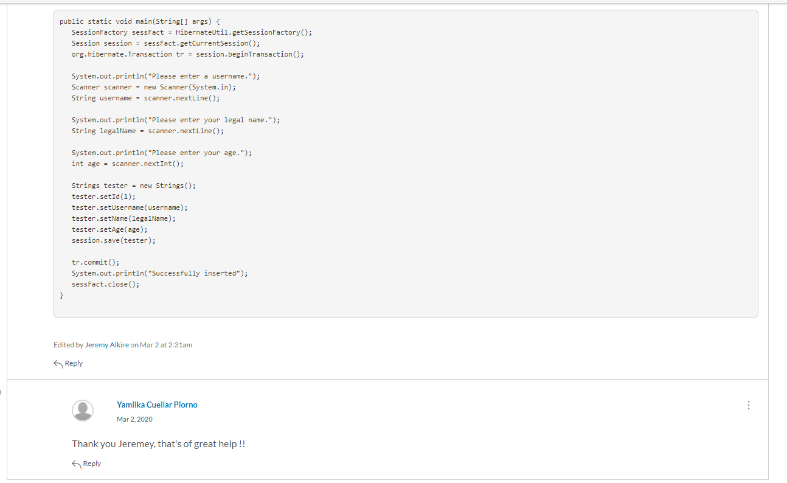

#5

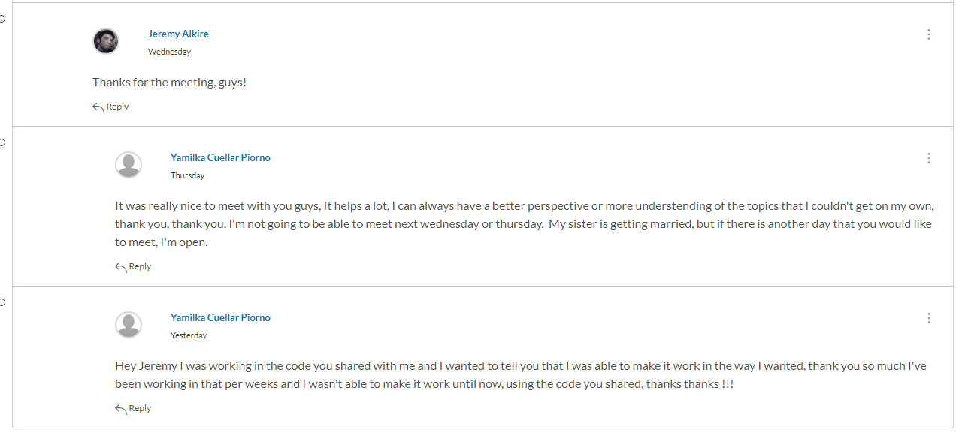

1. **Self-Reflection/Meta-Cognition:**

Upon reflection over the last four weeks, I don’t think there’s much I could have done to improve, barring better participation in the developer forum. I also can tell that my teammate Logan needed more assistance, though I’ve sadly been too hard-pressed on time to meet with him outside of our scheduled meeting times. If I assess my performance over the entire semester, I likely should have submitted my familiarity requests more frequently, rather than bundling it all up into two bulk submissions.

1. **Team's Agile Methodology:**

My team chose to use the Kanban approach to collaboration, although due to the chosen meeting times thus far I’ve not had a chance to collaborate with them on this. I think if a link was posted to some sort of collaborative Kanban board site, such as Trello, we could collaborate on this even without getting the chance to meet via video.  
  
In our most recent meetings we didn’t really utilize this, probably because we’re doing independent work as opposed to a group project, which I feel makes sense.

1. **Professional Scheduling Group:**

Group scheduling was a challenge this semester. If you look over my interactions with my teammates in our group discussion board, it was frequently a problem. I empathize sorely with tight schedules and life circumstances that make scheduling difficult for people (I am no exception to this), but most of our meetings were deliberately scheduled during my work hours, even after I explicitly stated that I’d be at work during those times. I had stressed this numerous times in our group discussion board, and meetings were still repeatedly scheduled during my hours of unavailability.  
  
That said, this isn’t something I hold against anyone. My group wanted to be time-efficient, and that meant meeting whenever they could, even if I wasn’t available. They did their best (in our most recent few meetings) to try and extend their meeting times into my hours of availability. For instance, if they started at 7:30 PM MST and knew I was not available until 9:30 PM MST, they’d try to keep the meeting going until then and after. However, that composed only a small fraction of the meetings. I missed most due to the times they were scheduled, though I did my best to assist in the meetings that I did manage to make it to, which is a statement that I think my group members will support.